EXPERIMENT:08
QUESTION:
- Which of the student’s score is greater than the average score?
SQL QUERIES:
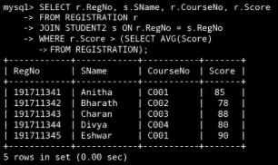
2. Which of the students’ have written more than one assessment test?
SQL QUERIES:
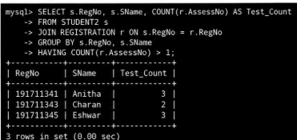
3. Which faculty has joined recently and when?
SQL QUERIES:
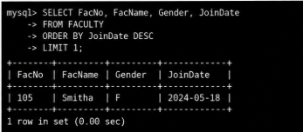
4. List the course and score of assessments that have the value more than the average score each Course
SQL QUERIES:
